IS117 Project 2-5 Page Website

By Jalen Moorer

**Github:** <https://github.com/JalenMoorer/Triumph-of-the-Nerds>

**Website:** <http://web.njit.edu/~jmm77/is117/final/index.html>

**Summary:** This website is basically just a summary about PC and Apple and how they managed to get their rise in the industry. The website simply highlights the key points that led them to their success, as well as their strategies for doing so. This website also shows the contrasts between Microsoft and Apple’s marketing strategies and overall intentions as well.

**Homepage**

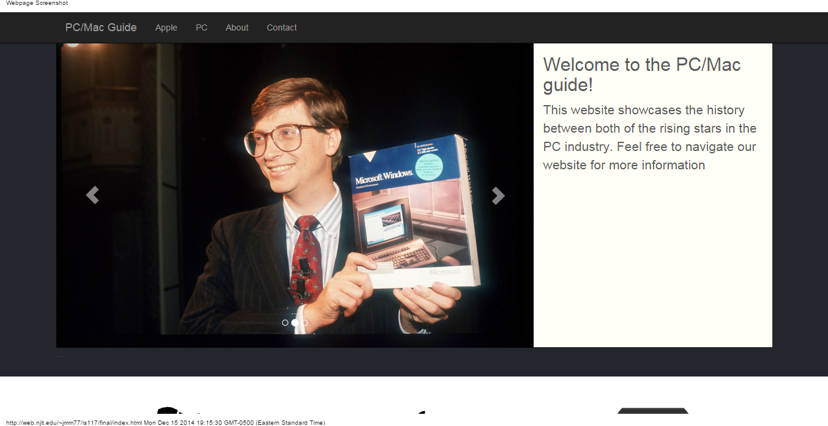

**Apple**

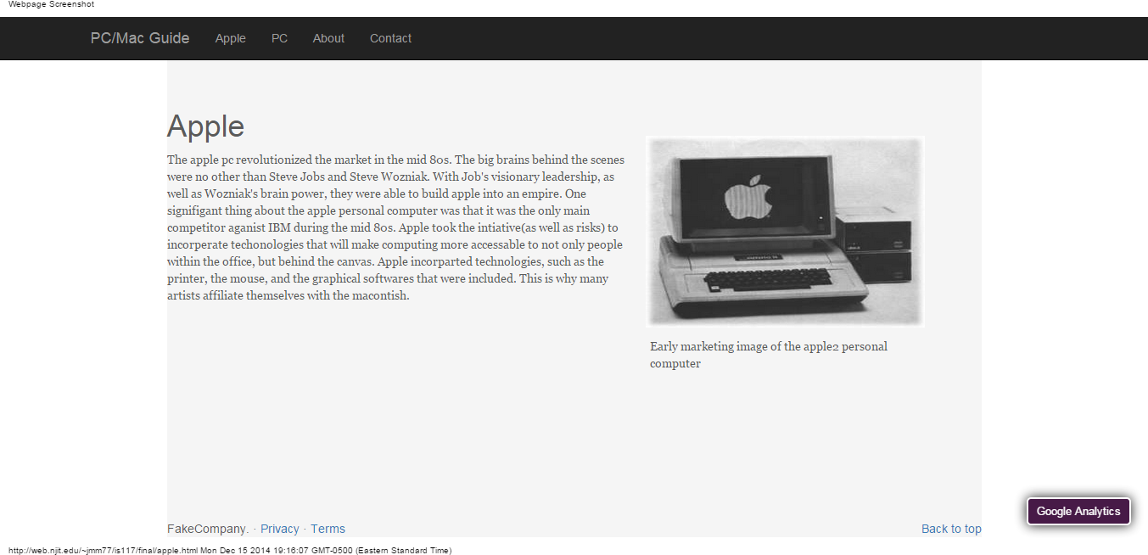

**PC**

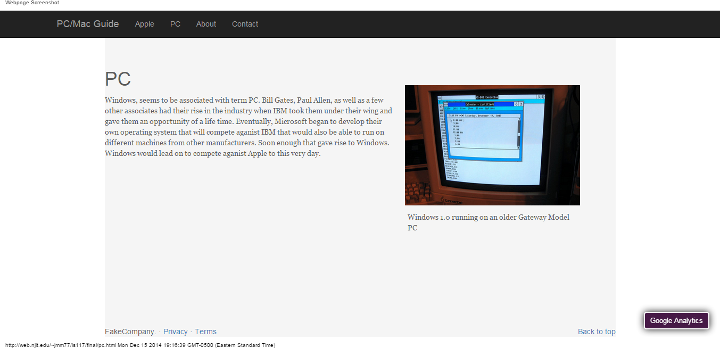

**About**

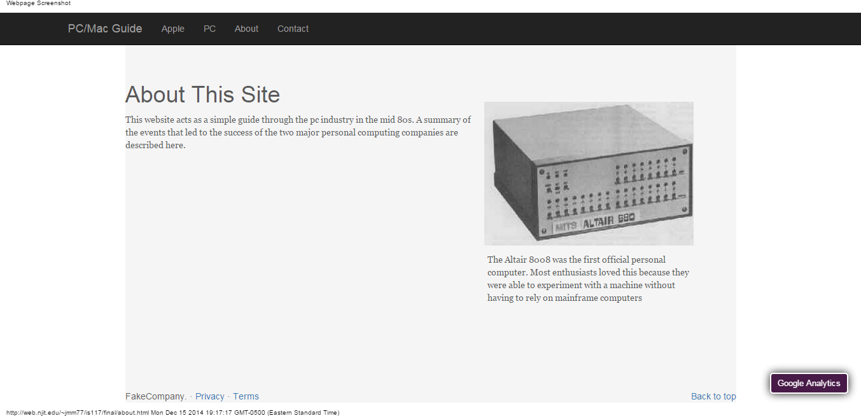

**Contact**

